

Department of Information Technology

University of Gujrat

CharitAble for U-O-G

LOGO

Session : MSc CS Spring 2019-2021

Project Advisor: Mr. Zaheer Ahmed

Submitted By

Qandeel Zulfiqar | 19010819-074
Muhammad Awais | 19010819-111
Iqra Hassan | 19010819-087

Department of computer science
University of Gujrat

STATEMENT OF SUBMISSION

This is certify that Qandeel Zulfiqar Roll No. 19010819-074,Muhammad Awais Roll No. 19010819-111and Iqra Hassan Roll No. 19010819-087 has successfully completed the final year project named as UOG CharitAble at the Department of Information Technology, University of Gujrat, to fulfill the requirement of the degree of Master of sciences in computer science

______________________ _____________________
Project Supervisor Project Coordination Office
Faculty of C&IT -UOG

______________________
Head of the Department

Acknowledgement

We truly acknowledge the cooperation and help make by Mr. Mubashir Hussain Chairman, Department of Information Technology, University of Gujrat. He has been a constant source of guidance throughout the course of this project. We would also like to thank Mr. Zaheer Ahmed for his help and guidance throughout this project. We are also thankful to our friends and families whose silent support led us to complete our project.

1- Qandeel Zulfiqar
2- Muhammad Awais
3- Iqra Hassan

Date: June 10, 2021

Abstract

The basic idea of UOG CharitAble to provide user friendly website for charity. Through this website students can help other students who are financially poor any person who individually want to help needy students. In this the term Donor is used for those people who want to help student and the term volunteer is used for the person or student who is needy in other words who is seeking for the help. There are many sites which are providing charity or scholarship opportunities to the students so here is the question why we are providing this platform to students where there are many other platforms for students then the main point is this here the donor or volunteer can directly communicate with each other, students can help each other directly without involving any departmental or other faculty.
This charity platform is just for the UOG students. In this our donor can help independently without involving any other faculty authority. It is full responsive website. The user can be open this web on Mobile phones, iPhone, PC, and Android. When the application is applied on server the user can search the web on Google chrome. The aim of this project is Create a website, electronic Charity that needy people can Take advantage of a range of Donors can also offer their charity at the UOG CharitAble,

Table of Contents
Chapter 1: Project Feasibility Report 7
1.1. Introduction 7
1.2. Project/Product Feasibility Report 8
1.2.1. Technical Feasibility 8
1.2.2. Operational Feasibility 9
1.2.3. Economic Feasibility 9
1.2.4. Schedule Feasibility 9
1.2.5. Specification Feasibility 9
1.2.6. Information Feasibility 10
1.2.7. Motivational Feasibility 10
1.2.8. Legal & Ethical Feasibility 10
1.3. Project/Product Scope 10
1.4. Project/Product Costing 10
1.4.1. Project Cost Estimation By Function Point Analysis Error! Bookmark not defined.
1.4.2. Project Cost Estimation by using COCOMO’81 (Constructive Cost Model) Error! Bookmark not defined.
1.4.3. Activity Based Costing 15
1.5. Task Dependency Table 15
1.6. CPM - Critical Path Method 15
1.7. Gantt chart 16
1.8. Introduction to Team member and their skill set 17
1.9. Task and Member Assignment Table 17
1.10. Tools and Technology with reasoning 17
1.11. Vision Document 17
1.12. Risk List 17
Chapter 2: Software Requirement Specification (For Object Oriented Approach) 19

2.1 Introduction 20
2.2 Systems Specifications 20
2.2.1 organization chart 20
2.2.2 Existing System 20
2.2.3 Scope of the System 20
2.2.4 Summary of Requirements:(Initial Requirements) 21
2.2.5 Identifying External Entities: 21
2.2.6 Capture "shall" Statements: 22
2.2.7 Allocate Requirements: Error! Bookmark not defined.
2.2.8 Priorities Requirements: 24
2.2.9 High Level Usecase Diagram: 25
2.10. Analysis Level Usecase Diagram: 26
2.11. Usecase Description 27
Chapter 3: Design Document (For Object Oriented Approach) 36
3.1. Introduction: 36
3.2. Sequence Diagram 37
3.3 Defining a Sequence diagram 38
3.4. Design Class Diagram 39
3.5. Data Model 40
Chapter 3: Software Requirement Specification and Design Document (For structured Approach) 41
3.1. Introduction: 42
3.2. Entity Relationship Diagram: 42
3.3. Data flow diagram (Functional Model) 43
3.4. State Transition Diagram 44
3.5. Architectural design 45
3.6. Component Level Design 45
Chapter 4: User Interface Design 45
4.1. Introduction 50
4.2. Site Maps 51
4.3. Story boards 51
Chapter 5: Software Testing 54
5.1 Introduction: 55
5.2. Test plan 55
7.2.1. Purpose 55
7.2.2. Outline 56
5.3. Test design specification 60
5.3.1. Purpose 60
5.3.2. Outline 60
5.4. Test Case Specification 64
5.4.1. Purpose 64
5.4.2. Outline 64
5.5. Test procedure specification 65
5.5.1. Purpose 65
5.5.2 Outline 66
5.6. Test item transmittal report 68
5.6.1. Purpose 68
5.6.2. Outline 68
5.7. Test log 70
5.7.1. Purpose 70
5.7.2. Outline 71
5.8. Test incident report 76
5.8.1. Purpose 76
5.8.2. Outline 76
5.9. Test summary report 77
5.9.1. Purpose 77
5.9.2. Outline 77
Appendixes: 79
Appendix 1: Final Documentation Format Guidelines 80

Chapter 1: Project Feasibility Report

Introduction
The existing of “CaritAble for UOG” is handled manually. In the ChartAble for UOG we are providing the charity to the UOG students in this we have three entities which are donor, volunteer and admin. In this donation system donor and volunteer can contact directly to each other for donations.
In this admin approve the volunteer by checking the profile or information which is provided by the volunteer and admin can also check the donor profile and donations history. The CharitAble for UOG is for those students who are seeking for help and for those student who wants to help needy students.
In this system students can help and directly in other words donor may be a student or may be a faculty member can help needy student without any interfere of faculty authorities. The term which is used for needy student that is volunteer

1.2. Project/Product Feasibility Report
The most basic purpose of that feasibility study to represent the main problem and then we also determine the solution to related problem after completing the feasibility study of that project. It revealed the level/scope, limitations and basic importance, or need of that system. It also represents concern to undertake that project or, not and all level of scheduling, defining, project planning must fulfill here. This study provides complete description alsothen the feasibility report will provide the following basic contents:
- Technical
- Operational
- Economic
- Schedule
- Specification
- Information
- Motivational
- Legal and Ethical

1.2.1. Technical Feasibility
the main consideration is to be given the study of the available resources of the organization where the software is to be implemented. Gere the system analyst evaluates the technical merits of the system given emphasis on the performance, reliability, maintainability, and productivity
By taking the consideration before developing the proposed system, the resources availability of the organization was immense computer facilities equipped with sophisticated machine and the software hence this technically feasible.
There are also some core tools and technologies that will be a part of this project.

Language / Technology | Tools | Reason | Hand Side
HTML | Adobe Dreamweaver  Or  Apache NetBeans | Development of Front end | Front Hand / User Interface
CSS | Adobe Dreamweaver  Or  Apache NetBeans | Designed User Interface for Iteration. | Front Hand / User Interface
JavaScript for Validation | Adobe Dreamweaver  Or  Apache NetBeans | Use to validate data which is entered by User | User Validation
PHP | Adobe Dreamweaver  Or  Apache NetBeans | Back Hand Code to get Data from User and Store in Database | Back Hand Side
MySQL | Apache SQL XAMPP Server | Use as Local Database Server to Store Records | Back Hand Side use to Store Data in Database

1.2.2. Operational Feasibility
operational feasibility contains the concept that the specific team member that completes the project must expert enough and skilled. It is also feasible that the project is able to provide the solution for underlying problem. This Charity system will remove the concept of manual work which means in this donor and volunteer can directly communicate with each another, and must provide responsive and will give efficient performance in its nature. Problem can be removed accurately.

1.2.3. Economic Feasibility
economic feasibility is the most important and frequently used method for evaluating the
effectiveness of the proposed system. It is very essential because the main goal of the
proposed system is to have economically better result along with increased efficiency. Cost benefit analysis is usually performed for this purpose. It is the comparative study of the cost verses the benefit and savings that are expected from the proposed system. Since the organization is well equipped with the required hardware was found to be economically.
This system will provide economic benefits to its users, basic two types of it are as follow:
- “Cost Estimates”

This cost estimation provides the total cost related to whole project
Acquisition Cost= laptop =30,000
Maintenance and Operation Cost= 40,000

- “Benefit Estimates”

Benefits estimation provides detail of tangible and in tangible benefits of that project.
- Tangible Benefits:
It calculates the monetary detail of the project; benefits are as written:
- It will improve the process of charity.
- There is no Cost for the services
- It will be efficient in time saving term and provide the fast Charity system
- Intangible Benefits:
These tangible benefits not contain any monetary term, this project con the following intangible benefits:
- It increases the responsibilities.
- Accurate access on the data,
- Decision making is very efficient and time saving.
- Prefer direct communication of donor and volunteer
- Better response on volunteer request.
- Data entry possible with in suitable time.
- It avoids the miss-utilization of the available resources/services.

1.2.4. Schedule Feasibility

It is very important that this project must complete in the earliest time. In order to fulfill that condition. We will use the “critical path method “term. This method will divide the relative task, will define the activities and relationship between these activates also dependencies. And finding on critical path that indicate the earliest star and finish time to our project task. This “CPM” most first method to complete the whole project.

1.2.5. Specification Feasibility
This is a management system, according to this project user needs and requirements are basic of this project we will involve user requirements specification documentation and also an analysis on these user requirements. It will indicate that what type of functionality is the part of this project. It will provide whole detail of functional and Non-functional specifications.

1.2.6. Information Feasibility
In order to complete the whole project, this system must divide in different related task and various important activities and there would time period for the completion of these activities.It will represent project reliability in all conditions. And then if it will perform all activities and functionality in accurate manners and promote to automate all these activities this will be perfect in projects nature.

1.2.7. Motivational Feasibility
Evaluation of the client staff regarding the motivation to perform the necessary steps correctly and promptly must occur.

1.2.8. Legal & Ethical Feasibility
This project totally contains the legal and ethical feasibility term everything of this project is legal and reliable for use, tools that will be used and provided by the university in order to finalize that project are accurate and legal in nature. Then we prefer the use of “Microsoft Visio” and online tools on creatly

1.3. Project/Product Scope
This system is only for the UOG students in the outsider students or those students who are not the UOG students cannot get any help the CharitAble only work in UOG for the UOG students. Students who wants to help those students who are financially poor can help easily. The student who want to get financial help for study can ask for help on the website where he/she can get financial help by a Donor.

1.4. Project/Product Costing

1.4.1. Project Cost Estimation by Function Point Analysis

Function-oriented software metrics use a measure of the functionality delivered by the application as a normalization value. Since ‘functionality’ cannot be measured directly, it must be derived indirectly using other direct measures. Function-oriented metrics were first proposed by Albrecht, who suggested a measure called the function point. Function points are derived using an empirical relationship based on countable (direct) measures of software’s information domain and assessments of software complexity.
Function Point Analysis can provide a mechanism to track and monitor scope creep. Function Point counts at the end of requirements; analysis, design, code, testing and implementation can be compared. The function point count at the end of requirements and/or designs can be compared to function points delivered. If the project has grown, there has been scope creep. The amount of growth is an indication of how well requirements were gathered by and/or communicated to the project team. If the amount of growth of projects declines over time it is a natural assumption that communication with the user has improved.
Function points are computed by completing the table shown in the figure below. Five information domain characteristics are determined and counts are provided in the appropriate table location.
Parameter | Low | Medium | High
User Inputs | 3 | 4 | 6
User Output | 4 | 5 | 7
User Inquiries | 3 | 4 | 6
Internal files | 7 | 10 | 15
External interface | 5 | 7 | 10

Information domain values are defined in the following manner:

Number of user inputs: 12

Number of user outputs: 3
Number of user inquiries: 3

Number of files: 4
Number of external interfaces: 5

The formulae are given as follows:

Cost / FP = labor rate / productivity parameter

Total Project Cost = FP est. * (cost / FP)

Total Estimated Effort = FP est. / productivity parameter

To Find UFC:-
No. of user inputs =3(low) + 3 (medium) +6 (high)
No. of user inquiries= 2(med) + 1(high)
No. of user outputs= 3 (high)
No. of internal files= 2 (med)
No. of external interface files= 0

- No. of unadjusted functional points (UFP) = (3*3) + (3*4) + (6*6) + (2*4) + (1*6) + (3*7) + (2*10) = 112

Technical COMPEXITY FACTOR

SR. NO | FACTORS | DEGREE
1 | Data communication | 2
2 | Distributed data processing | 2
3 | Performance criteria | 3
4 | Heavily utilized hardware | 4
5 | Fast Processing | 3
6 | Online Data Entry | 3
7 | Online Updating | 1
8 | End user efficiency | 2
9 | Complex computations | 1
10 | Reusability | 3
11 | Ease of installation | 2
12 | Ease of operation | 3
13 | Probability | 2
14 | Maintainability | 2

TABLE 2: To find Technical COMPLEXITY FACTOR
Degree of influence= 33

- Technical Complexity Factor(TCF):-
TCF=0.65+0.01*DI
TCF= 0.65+0.01*33
= 0.98

- FUNCTION POINTS:
Function points (FP)= UFP*(TCF)
= 112*(0.97)
= 108.64

1.4.2. Project Cost Estimation by using COCOMO’81 (Constructive Cost Model)

The Constructive Cost Model (COCOMO) is a procedural software cost estimation model developed by Barry W. Boehm. The model parameters are derived from fitting a regression formula using data from historical projects.

COCOMO 81 model estimate for the project cost by nominal effort involving set of multipliers and development time for that project by selecting its mode.

For project mode selection, we have to look for table that contains certain features, and all three modes that are organic, semi-detached and embedded. Mode will be selected according to scaling done for these features. These estimation for mode selection are given below:

Feature | Organic | Semi detached | Embedded
Organizational | Thorough | Considerable | General
understanding of
product objectives
Experience in | Extensive | Considerable | Moderate
working with related
software systems
Need for software | Basic | Considerable | Full
conformance with
pre-established
requirements
Need for software | Basic | Considerable | Full
conformance with
external interface
specifications.
Concurrent | Some | Moderate | Extensive
development of
associated new
hardware and
operational
procedures
Need for innovative | Minimal | Some | Considerable
data processing
architectures,
algorithms
Premium on early | Low | Medium | High
completion
Product Size Range | <50 KDSI | <300 KDSI | All sizes

As answer to most questions lie in organic mode, so we will select this mode for our project whose value is:

© University of Gujrat
21
- Organic mode:
Nominal Effort =3.2 (KDSI) ^1.05*M

TDEV = 2.5 (Effort) ^0.38

We will do product’s rating to determine set of effort multipliers on a set of 15 cost driver attributes:

Cost Driver |  | Very | Low | Nominal | High | Very |  | Extra
 |  | Low |  |  |  | High |  | High
 | Product Attribute
 | Required Software | 0.75 | 0.88 | 1.00 | 1.15 | 1.40 |  | -
 | Reliability | 0.75
 | Database size | - | 0.94 | 1.00 | 1.08 | 1.16 |  | -
 | Product Complexity |  |  |  |  |  |  | -
 |  | 0.70 | 0.85 | 1.00 | 1.15 | 1.30 |  | 1.65
 | Computer Attribute
 |  | - | -
 | Execution time | - | - | 1.00 | 1.11 | 1.30 |  | 1.66
 | constraints |  |  | 1.00 | 1.11 | 1.30 |  | 1.66
 | Storage Constraints | - | - | 1.00 | 1.06 | 1.21 |  | 1.56
 | Virtual Machine |  |  |  |  |  |  | 1.56
 | Volatility | -
 | Computer Turnaround | -
 | Computer Turnaround |  | 0.87 | 1.00 | 1.15 | 1.30 |  | -
 | Time |  |  |  |  |  |  | -
 |  | -
 |  |  | 0.87 | 1.00 | 1.07 | 1.15 |  | -
 | Personal Attribute
 |  | 1.46 | 1.19 | 1.00 | 0.86 | 0.71 |  | -
 | Analyst Capability
 | Application
 | Experience | 1.29 | 1.13 | 1.00 | 0.91 | 0.82 |  | -
 | Programming |  |  |  |  |  |  | -
 | Capability | 1.42 | 1.17 | 1.00 | 0.86 | 0.70 |  | -
 | Virtual machine |  |  |  |  |  |  | -
 | experience | 1.21 | 1.10 | 1.00 | 0.90 | - |  | -
 | Prog. language |  |  |  |  |  |  | -
 | Prog. language | dfdf
 | experience
 |  | 1.14 | 1.07 | 1.00 | 0.95 | - |  | -
 | Project Attribute

Modern programming
practice |  | 1.24 | 1.10 | 1.00 | 0.91 | 0.82 | -
Use of software tools
Development schedule
 |  | 1.24 | 1.10 | 1.00 | 0.91 | 0.83 | -
 |  | 1.23 |  | 1.00 | 1.04 | 1.10 | -

Type | Effort | Schedule
Organic | PM= 2.4 (KLOC)1.05 | TD= 2.5(PM)0.38
Semi-Detached | PM= 3.0 (KLOC)1.12 | TD= 2.5(PM)0.35
Embedded | PM= 2.4 (KLOC)1.20 | TD= 2.5(PM)0.32

PM= person-month (effort)

KLOC= lines of code, in thousands

TD= number of months estimated for software development (duration)

People Required = Effort / Duration

As our project is organic, we will use equations of organic type:

Estimated KLOC in our project is 15

KLOC=15
PM= 2.4 (KLOC)^{1.05}
PM=2.4(15)^{1.05}
=41 person-month
TD= 2.5(PM)^{0.38} = 2.5(41.21)^{0.38} = 10
People Required = Effort / Duration

= 41/10 = 4

1.4.3. Activity Based Costing

 | Sr. |  |  | Activities |  |  | Resources |  |  | Cost Rate |  |  |  | Duration
1 |  |  |  | Website Design, Layout, |  |  | Bootstrap |  |  | 5K |  | 4
 |  |  |  | Structure
2 |  |  |  | Front End |  |  | HTML, CSS, |  |  | 5K |  | 1
 |  |  |  |  |  |  | JavaScript
3 |  |  |  | Development of website |  |  | Bootstrap |  |  | Free |  | 8
 |  |  |  | components
4 |  |  |  | Back End |  |  | XAMPP |  |  | 5K |  | 7
 |  |  |  |  |  |  | Distribution

1.5. Task Dependency Table
The following are the steps to develop a task dependency table:
Task-No. | Task-Name | Dependent-on
T1 | Requirement Gathering
T2 | Analysis | T1
T3 | Design | T2
T4 | Coding | T3
T5 | Defining the backend structure | T5
T6 | Server-Side Logic | T6
T7 | Testing | T4, T5, T6
T8 | Deployment | T4, T5, T6, T7

1.6. CPM - Critical Path Method
1. Determine the Sequence of the Activities
Task ID | Task Description | Duration (Days) | Dependencies
 | Start | -
A | Communication | 7 | -
B | Planning | 7 | A
C | Modeling | 14 | A, B
D | Construction | 21 | B, C
E | Deployment | 30 | D

2. Draw the Network Diagram
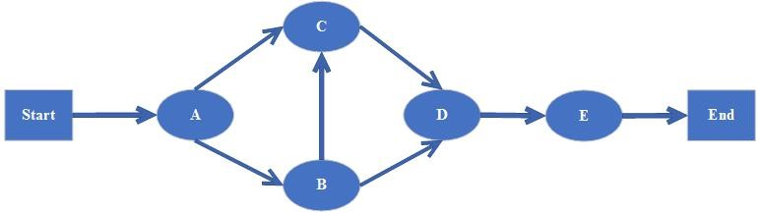
3. Estimate Activity Completion Time
Task ID |  |  | Predecessors |  |  |  | Duration(days)
A |  |  | - |  |  |  | 15
B |  |  | A |  |  |  | 15
C |  |  | A, B |  |  |  | 30
D |  |  | B, C |  |  |  | 40
E |  |  | D |  |  |  | 20
4.Identify the Critical Path
Activity | Duration | ES |  | EF | LS | LF |  | TS | FS
A | 15 | 1 |  | 16 | 1 | 16 |  | 0 | 0
B | 15 | 16 |  | 31 | 16 | 31 |  | 0 | 0
C | 30 | 16 |  | 46 | 1 | 31 |  | 15 | 15
D | 40 | 31 |  | 71 | 31 | 71 |  | 0 | 0
E | 20 | 71 |  | 91 | 71 | 91 |  | 0

1.7. Gantt chart
The Gantt chart enumerates the activities to be performed on the vertical axis and their corresponding duration on the horizontal axis. It is possible to schedule activities by either early start or late start logic. In the early start approach, each activity is initiated as early as possible without violating the precedence relations. In the late start approach, each activity is delayed as much as possible as long as the earliest finish time of the project is not compromised.
Based on the Work Breakdown Structure (WBS), a timeline or Gantt chart showing the allocation of time to the project phases or iterations should be developed. This Gantt chart would identify major milestones with their achievement criteria. It must contain duration estimation of all the necessary activities to be carried out during the project development along with the human resources responsible for the respective tasks. Activity dependencies are also required to be mentioned in it.

1.8. Introduction to Team member and their skill set
The project team consists of 3 members. Each member is technical skilled and perform every task with very efficient way. Every team member performs their task in time due to their technical expertise.

1.9. Task and Member Assignment Table
No. | Activity | Duration | Deliverables
 | Idea Discussion | 7 | Proposal Document
 | Requirement Analysis | 7 | SRS
 | Prototyping | 7 | Wireframes and UI
 | Design Phase | 21 | UML Diagrams
 | Implementation | 14 | Final Product
 | Testing against test cases | 15 | Testing Document

1.10. Tools and Technology with reasoning
The tool that is used for front-end Sublime that support web development work. We use query language in sql server. HTML language is used for web page designing.

- The HTML is used for frontend of our website.
- The CSS is used for styling of the website
- The JavaScript is used scripting
- The development model is used in our project is Prototype model.
- The language that we used in our project is PHP for server-side scripting.

- Platform that we used in our project is PHP.
- The framework that we used in our project is PHP.
- Database that we used in our project is SQL, Xampp.

We use these tools and technology because Sublime support this framework. Moreover, PHP language is very powerful language that also support for developing any type of web application.

1.11. Vision Document
Provide a modern-day charity platform based on web-based application use to provides about Charity which named as CharitAble for UOG.

Users:

- Admin
- Donor
- Volunteer

Key factor to judge the Quality:

- System is automated and provide solution of problems that occurred in manual auction

- Each user has facility to interact with his area of working.

- Users can register to avail Donation services.

- Implement modern technology.

- Users are notified about updates by notifications on the CharitAble portal.

Financial:

Development cost is minimum.

1.12. Risk List
Maintenance & Design Level Risks:

- Health factor of staff (illness issues).

- Effects of changes in requirements of project.

- Effects of restructuring in organization.

- Estimation: The development team might not be able to estimate the work time, preventing customers from deciding priorities effectively. The rate of defects repair is underestimated.

- Reusability: Reusability of modules can affect the functionality of the project.

- Acceptance: Market may accept web platform, if it will provide real time problem solution

- Scope: The total features requested may be beyond what the development team can deliver in the time available.

Software Level Risk:

- Immature technology with rapid changes in standard.

- No internet availability in most northern areas.

Technology Level Risk:

- The project will fail without web browser, internet and desktop.

Development Level Risks:

- Finance: There may be credit risk; the question is whether they have sufficient resources to manage the construction and operation of the project and to efficiently resolve any problems which may arise. To minimize this risk human resources are important (Limitation and resources).

- Time: Limited time available to complete this whole project as this project will

Chapter 2: Software Requirement Specification (For Object Oriented Approach)

2.1 Introduction

2.2 Systems Specifications
The following are the clauses that must be included while describing the system specifications.

2.2.1. Organization Chart
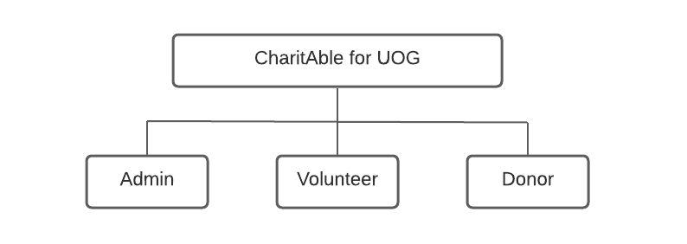

2.2.2. Existing System
The existing of “CaritAble for UOG” is handled manually. In the ChartAble for UOG we are providing the charity to the UOG students in this we have three entities which are donor, volunteer and admin. In this donation system donor and volunteer can contact directly to each other for donations.
In this admin approve the volunteer by checking the profile or information which is provided by the volunteer and admin can also check the donor profile and donations history. The CharitAble for UOG is for those students who are seeking for help and for those student who wants to help needy students.
In this system students can help and directly in other words donor may be a student or may be a faculty member can help needy student without any interfere of faculty authorities. The term which is used for needy student that is volunteer

2.2.3. Scope of the System

Phase I
It includes following business areas:
- Approve volunteer
- Make profiles
- Donors list
- Volunteers list
- Make donation
- Generate request
- Donations list
- Update lists

Phase II
It includes the following areas:

- Sign up

- Verification

Phase III
It includes all the remaining aspects which are not included in previous phases. It is the complete and comprehensive application of Online Career Guidance.

2.2.4. Summary of Requirements:(Initial Requirements)
The purposed system must fulfill following requirements as follow:
- Donor Dashboard
  - Select Volunteer & Donate
  - Donation History
  - Profile Updating
- Volunteer Dashboard
  - Generate Help Request
  - Verification of Received Donation
  - Donation History
  - Profile Updating
- Administrator Dashboard
  - Add New Member
  - Check Existing Member
  - Check Donor List
  - Check Volunteer List
  - Check Donations
  - Filtered Donation Report (Week, Month, Year)
  - Search Specific (Users, Donations)
  - Complain Box
  - Profile

2.2.5. Identifying External Entities:

The Identification of External Interfaces is done in two phases.

2.2.5.1. Over Specify Entities from Abstract

- Authentication

- View and manage record

2.2.5.2 Perform Refinement

Now we have refined these entities furthermore. Following entities are related to our project
- Login System
- Generate requests
- Make donations
- Check lists
- Update record

2.2.6. Capture "shall" Statements:

Para # | Initial Requirements
1.0 | A volunteer “shall” signup to create or make a profile.
1.0 | A donor “shall” signup to create or make a profile.
1.0 | The donor and volunteer “shall” login when they have signup once,
1.0 | volunteer “shall” make a request for the help
1.0 | A donor “shall” make donation by using this after selecting the volunteer.
1.0 | Donation make by the donor “shall” approve/accept by the volunteer.
1.0 | Volunteer or donor “shall” change their passwords when they want to change it.
1.0 | Admin “shall” generates the reports of donations
1.0 | Admin “shall” check the complains by the donor or volunteer, and also give the response for the complain.
1.0 | Admin “shall” check the lists or donor and volunteer who are existing in the system.
2.0 | Admin “shall” add a new admin when he needs for assistant/partner to divide his work.
2.0 | Admin “shall” check the existing admin or assistant admin.

2.2.7 Allocate Requirements:

Para # | Initial Requirements | Use Case Name
1.0 | A volunteer “shall” signup to create or make a profile. | UC_Volunteer_signup
1.0 | A donor “shall” signup to create or make a profile. | UC_Donor_signup
1.0 | The donor and volunteer “shall” login when they have signup once, | UC_login
1.0 | volunteer “shall” make a request for the help | UC_Request_Now
1.0 | A donor “shall” make donation by using this after selecting the volunteer. | UC_Donate_Now
 | Donation make by the donor “shall” approve/accept by the volunteer. | UC_Approve_donation
1.0 | Volunteer or donor “shall” change their passwords when they want to change it. | UC_Change_Password
1.0 | Admin “shall” generates the reports of donations | UC_Report
1.0 | Admin “shall” check the complains by the donor or volunteer, and also give the response for the complain. | UC_Complain
1.0 | Admin “shall” check the lists or donor and volunteer who are existing in the system. | UC_Volunteer/Donor_list
1.0 | Admin “shall” add a new member, where member may b a new admin or volunteer. | UC_Add_New_member
2.0 | Admin “shall” check the existing admin or assistant admin. | UC_Existing_Admin

2.2.8. Priorities Requirements:

Para # | Rank | Initial Requirements | Use Case ID | Use Case Name
1.0 | Highest | A volunteer “shall” signup to create or make a profile and A donor “shall” signup to create or make a profile. | UC_1 | UC_Volunteer/Donor_signup
1.0 | Highest | The donor and volunteer “shall” login when they have signup once, | UC_2 | UC_login
1.0 | Highest | volunteer “shall” make a request for the help | UC_3 | UC_Request_Now
1.0 | Highest | A donor “shall” make donation by using this after selecting the volunteer. | UC_4 | UC_Donate_Now
1.0 | Highest | Donation make by the donor “shall” approve/accept by the volunteer. | UC_5 | UC_Approve_donation
2.0 | Medium | Volunteer or donor “shall” change their passwords when they want to change it. | UC_6 | UC_Change_Password
2.0 | Medium | Admin “shall” generates the reports of donations | UC_7 | UC_Report
2.0 | Medium | Admin “shall” check the complains by the donor or volunteer, and also give the response for the complain. | UC_8 | UC_Complain
2.0 | Medium | Admin “shall” check the lists or donor and volunteer who are existing in the system. | UC_9 | UC_Volunteer/Donor_list
3.0 | Low | Admin “shall” add a new member, where member may b a new admin or volunteer. | UC_10 | UC_Add_New_member
3.0 | Low | Admin “shall” check the existing admin or assistant admin. | UC_11 | UC_Existing_Admin

2.2.9. High Level Usecase Diagram:

2.2.10. Analysis Level Usecase Diagram:

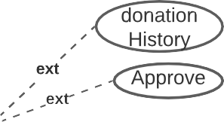

2.2.11. Usecase Description

2.2.11.1 Signup

Actor: volunteer/donor  UC ID: UC_1  UC Name: UC_Volunteer/Donor_signup | Developer: Q-A-H  Date: 9-July-2021
Precondition: Actor not have an account.

Main Scenario:

Actor’s Action

- Actor clicks on signup button

- Actor provides required information

System Response

- System asks for required information.

4. System shows search result.

Post Condition: Actor logs in to the website if provided data is correct.

Alternatives: Actor should signup first if haves no account already.

2.2.11.2 User Login

Actor: volunteer/donor  UC ID: UC_2  UC Name: UC_login | Developer: Q-A-H  Date: 9-July-2021
Precondition: Actor should have an account.

Main Scenario:

Actor’s Action

- Actor clicks on login button
- Actor provides required information

System Response

- System asks for required information.
- System shows search result.

Post Condition: actor logs in to the website if provided data is correct.

Alternatives: actor should signup first if haves no account already.

2.2.11.3 Generate request

Actor: volunteer  UC ID: UC_3  UC Name: UC_Request_Now | Developer: Q-A-H  Date: 9-July-2021
Precondition: Actor login in the system first.

Main Scenario:

Actor’s Action

- Actor clicks on Request Now
- Actor fill the form to make request.

- Actor provides required information

System Response

- System asks for required information.
- System shows search result.

Post Condition: Actor can make request when actor fill the form correctly.

Alternatives: Actor should login first.

2.2.11.4 Make donation

Actor: Donor  UC ID: UC_4  UC Name: UC_Donate_Now | Developer: Q-A-H  Date: 9-July-2021
Precondition: Actor login in the system first.

Main Scenario:

Actor’s Action

- Actor clicks on Donate Now
- Actor select the volunteer.

- Actor provides required information

System Response

- System asks for required information.
- System shows search result.

Post Condition: Actor can make donation when requests are generated and actor choose the volunteer.

Alternatives: Actor should login first.

2.2.11.5 Approve donation
Actor: volunteer  UC ID: UC_5  UC Name: UC_Approve_donation | Developer: Q-A-H  Date: 9-July-2021
Precondition: Actor should have receives donation offer by donor.

Main Scenario:

Actor’s Action

- Actor clicks on approve button to complete donation

- Actor provides required information

System Response

- System asks for required information.
- System shows search result.

Post Condition: Actor convert the donations pending status into complete status.

Alternatives: Actor should generate request.

2.2.11.6 Change Password

Actor: volunteer/admin/donor  UC ID: UC_6  UC Name: UC_Change_Password | Developer: Q-A-H  Date: 9-July-2021
Precondition: Actor should have login.

Main Scenario:

Actor’s Action

- Actor clicks on change password.

- Actor provides required information

System Response

- System asks for required information.
- System shows search result.

Post Condition: Actor secure the account.

Alternatives: Actor should signup.

2.2.11.7 Report

Actor: Admin  UC ID: UC_7  UC Name: UC_Report | Developer: Q-A-H  Date: 9-July-2021
Precondition: Actor should have login.

Main Scenario:

Actor’s Action

- Actor clicks on report button to generate report.

- Actor provides required information

System Response

- System asks for required information.
- System shows search result.

Post Condition: Actor have record report.

Alternatives: Actor should signup.

2.2.11.8 Complain

Actor: Admin  UC ID: UC_8  UC Name: UC_complain | Developer: Q-A-H  Date: 9-July-2021
Precondition: Actor should have login.

Main Scenario:

Actor’s Action

- Actor clicks on complain button to check complains or to make response.

- Actor provides required information

System Response

- System asks for required information.
- System shows search result.

Post Condition: Actor make response to complains.

Alternatives: Actor have no complain.

2.2.11.9 Volunteer/Donor_list

Actor: Admin  UC ID: UC_9  UC Name: UC_Volunteer/Donor_list | Developer: Q-A-H  Date: 9-July-2021
Precondition: Actor should have login.

Main Scenario:

Actor’s Action

- Actor clicks on Volunteer/Donor_list.

- Actor provides required information

System Response

- System asks for required information.
- System shows search result.

Post Condition: Actor have volunteers and donors list.

Alternatives:

2.2.11.10 Add New member

Actor: Admin  UC ID: UC_10  UC Name: UC_Add_New_member | Developer: Q-A-H  Date: 9-July-2021
Precondition: Actor should have login.

Main Scenario:

Actor’s Action

- Actor clicks on Add New member button.

- Actor provides required information

System Response

- System asks for required information.
- System shows search result.

Post Condition: Actor added new volunteer/admin.

Alternatives: Actor must find a admin.

2.2.11.11 Existing Admin
Actor: Admin  UC ID: UC_11  UC Name: UC_Existing_Admin | Developer: Q-A-H  Date: 9-July-2021
Precondition: Actor should have login.

Main Scenario:

Actor’s Action

- Actor clicks on Existing admin.

- Actor provides required information

System Response

- System asks for required information.
- System shows search result.

Post Condition: Actor have name of persons who are existing in system with admin authorty.

Alternatives: Actor must add new admin.

Chapter 3: Design Document (For Object Oriented Approach)

3.1. Introduction:
Third deliverable is all about the software design. In the previous deliverable, analysis of the system is completed. So we understand the current situation of the problem domain. Now we are ready to strive for a solution for the problem domain by using object-oriented approach. Following artifacts must be included in the 3rd deliverable.

- Sequence Diagram
- Defining a sequence diagram
- Design Class Diagram
- State Transition Diagram
- Data Model

Now we discuss these artifacts one by one as follows:

3.2. Sequence Diagram
→Sequence diagrams for volunteer
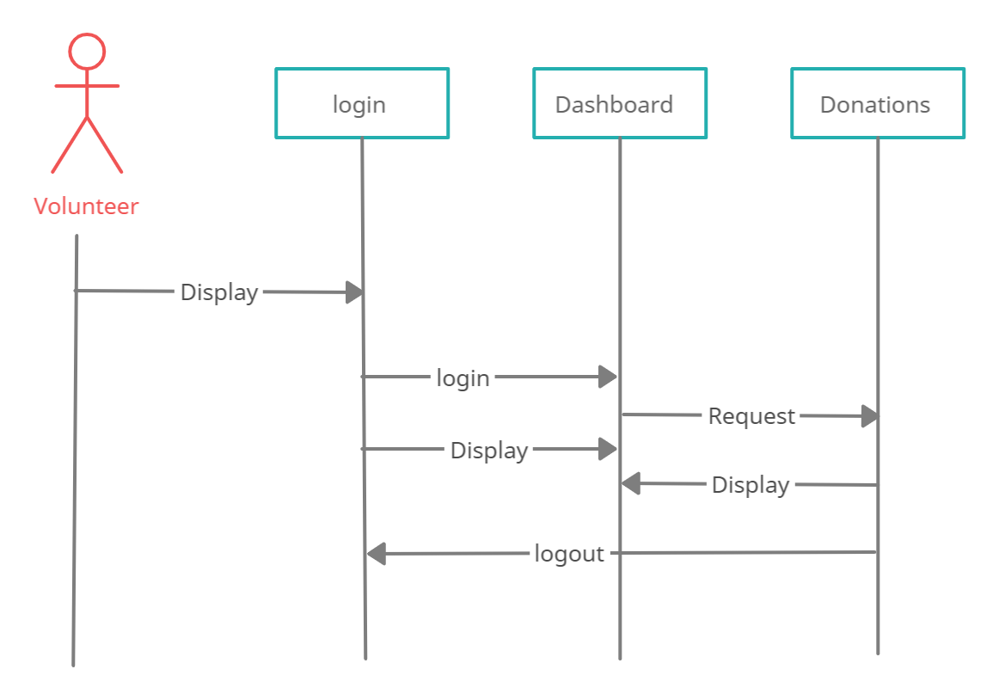

→Sequence diagrams For Donor
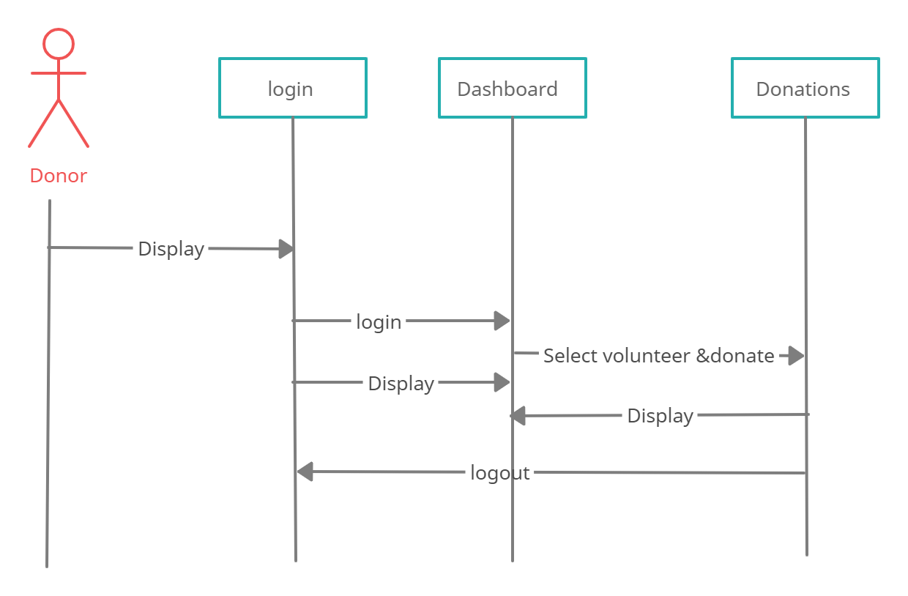
→Sequence diagrams For Admin
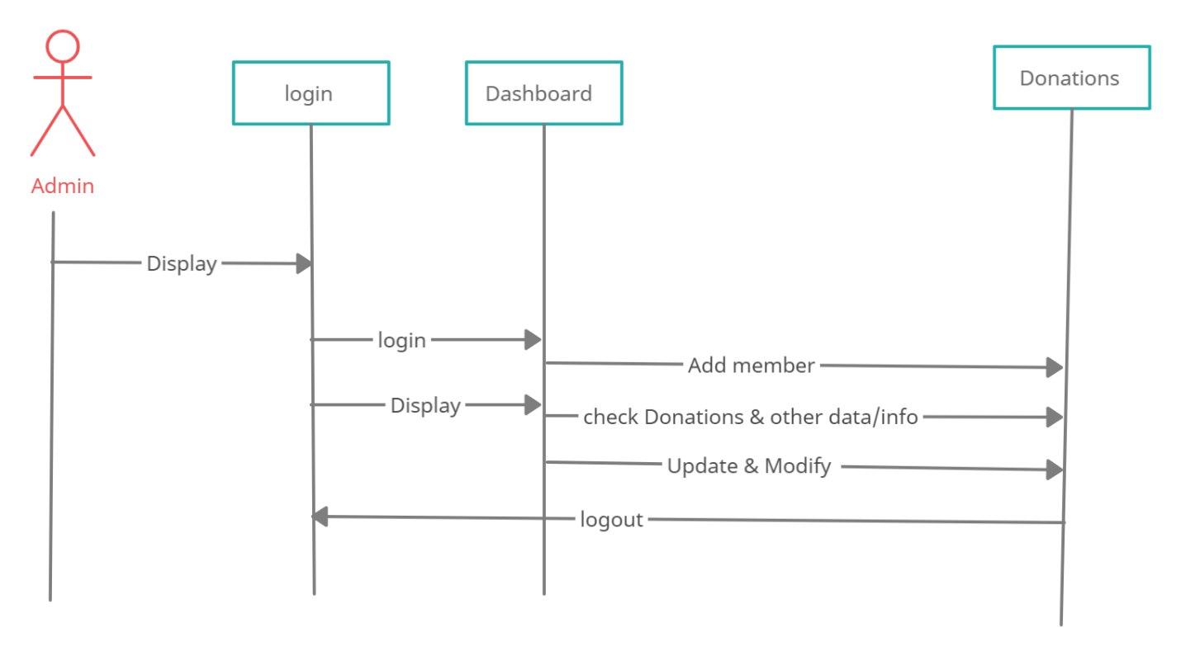

3.3. Defining a Sequence diagram
- Sequence diagram for Admin: shows that first admin login with his/her account then the admin can perform the activitied such as admin can add new member mean admin approve the the volunteer accounts, admin can check data about donations or donor or volunteer
- Sequence diagram for donor: show that donor login first with his/her account then donor can check the request of multiple volunteers then donor select a volunteer and make a donation to the volunteer.
- Sequence diagram for volunteer: this shows that to generate a request for help first volunteer login with the account then volunteer can generate a request for help and can approve the donation and can check other info like profile notifications etc.

3.4. Design Class Diagram
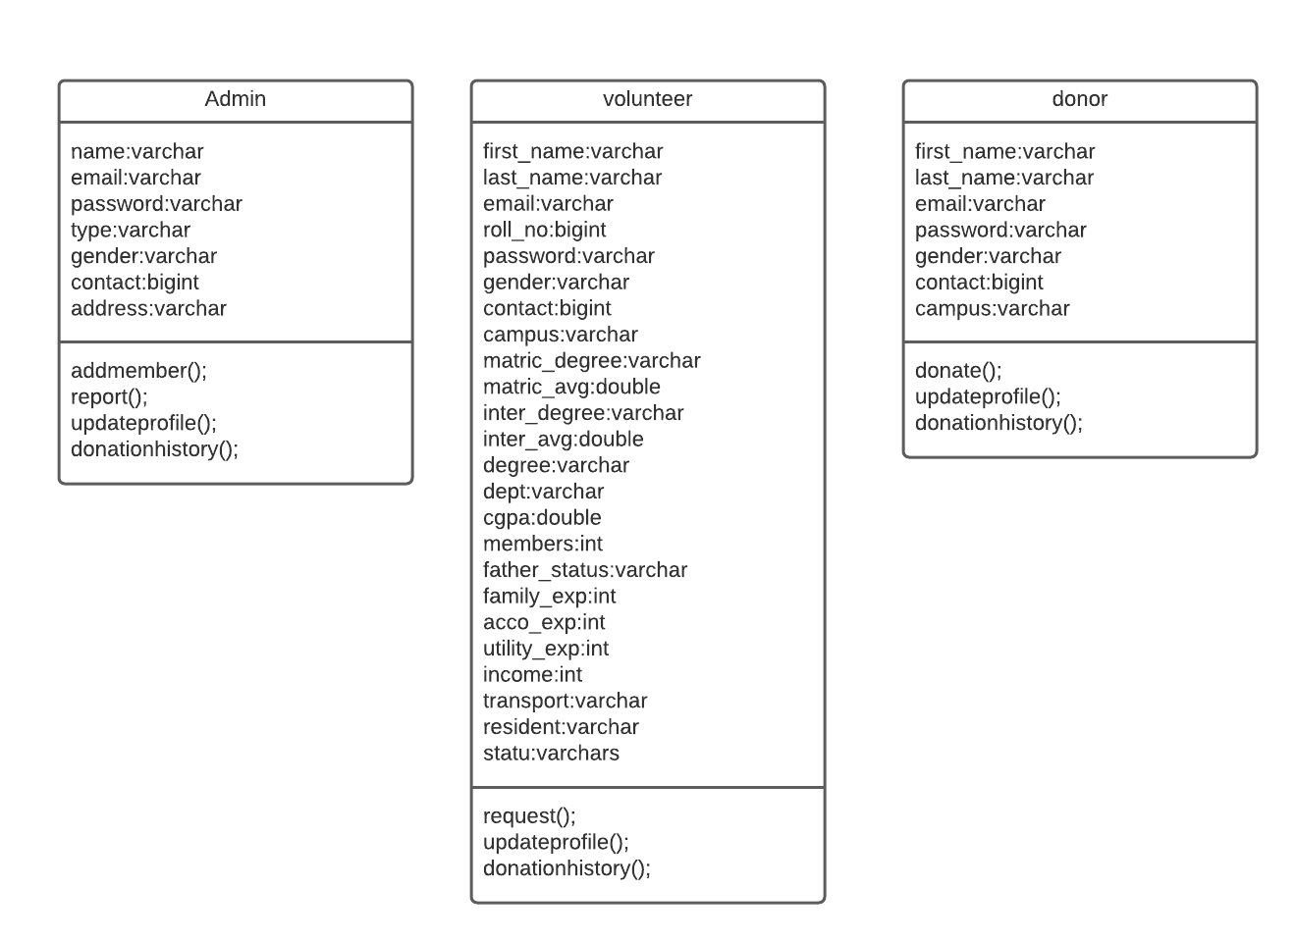

3.5. Data Model
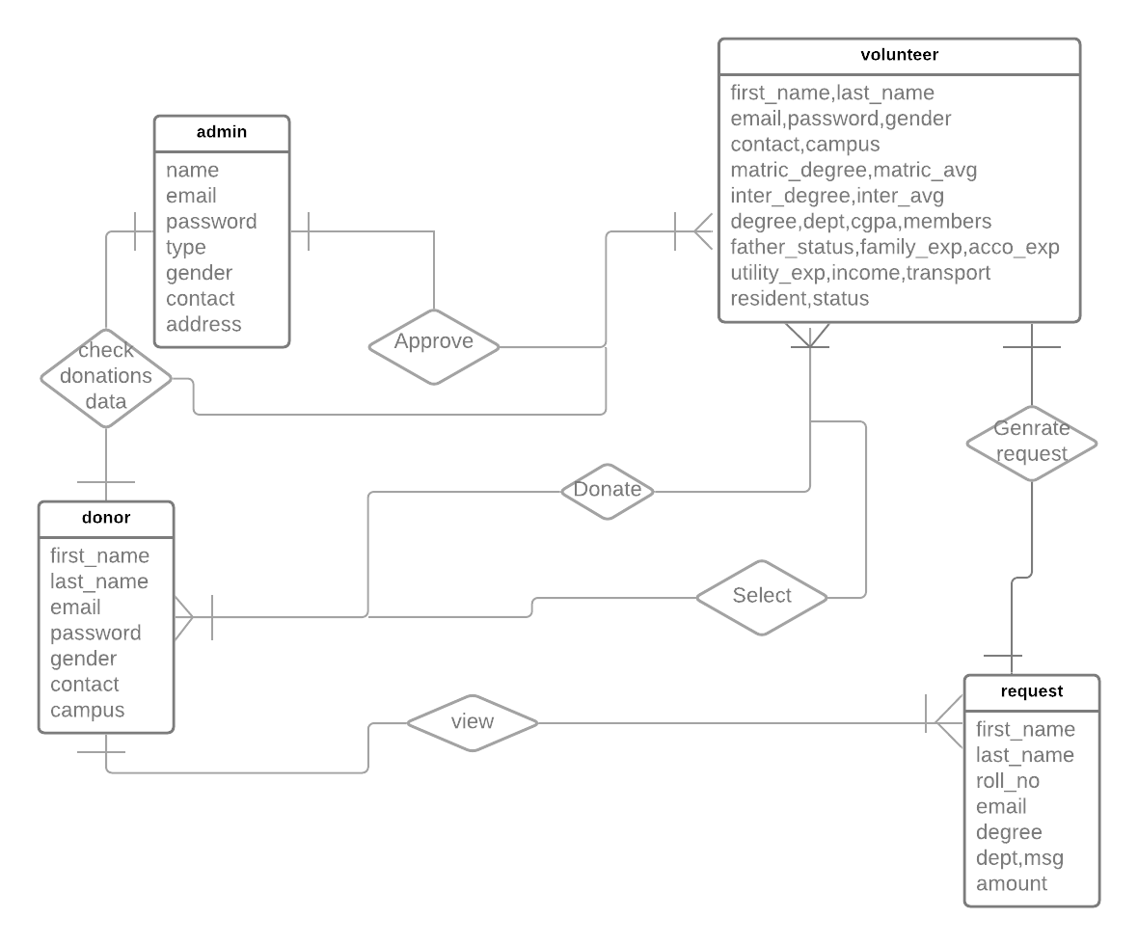

Chapter 3: Software Requirement Specification and Design Document (For structured Approach)

3.1. Introduction:
Analysis & Design Model for structured approach must contain following artifacts:

- Entity Relationship Diagram
- Data Flow Diagram (Functional Model)
- State Transition Diagram (Behavioral Model)
- Architecture Design
- Component Level Design

3.2. Entity Relationship Diagram:
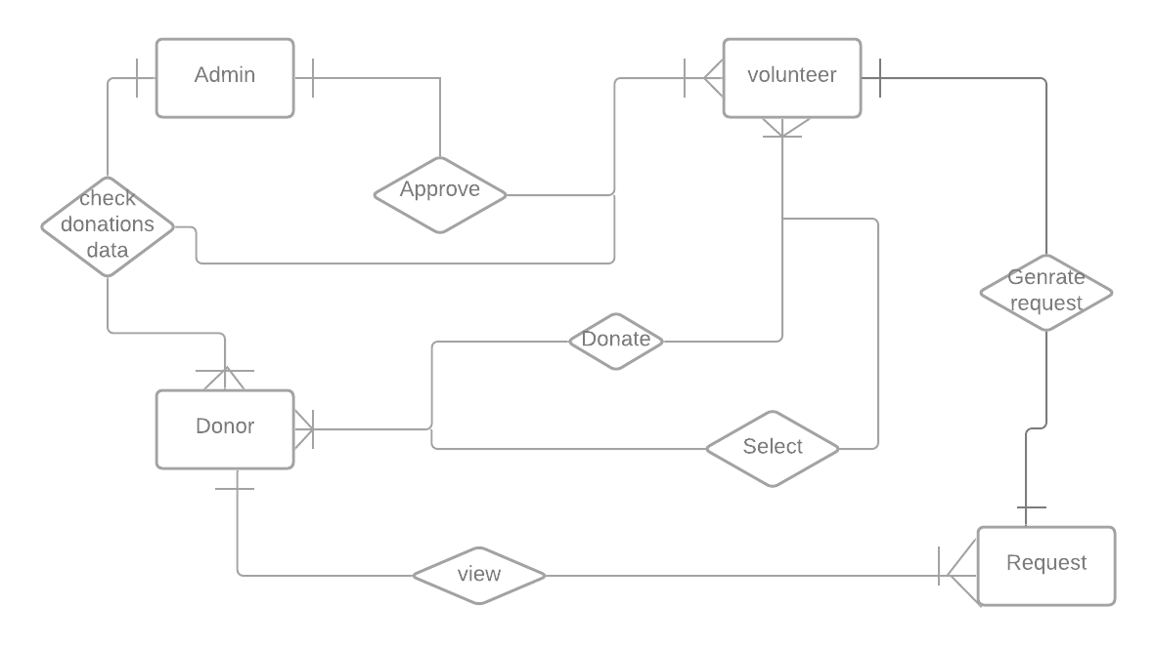

3.3. Data flow diagram (Functional Model)
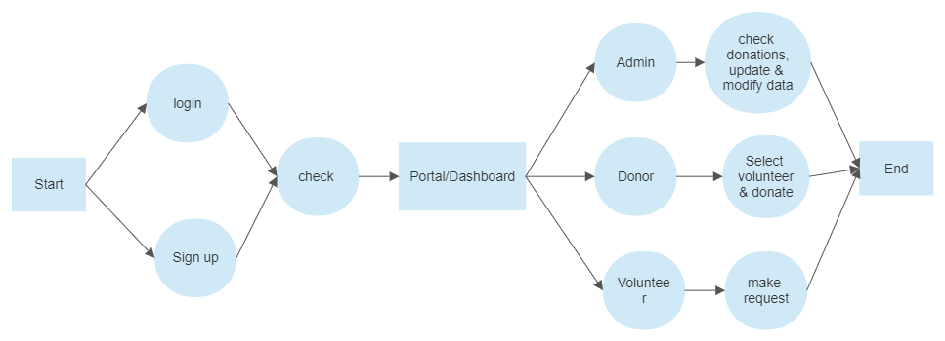

3.4. State Transition Diagram
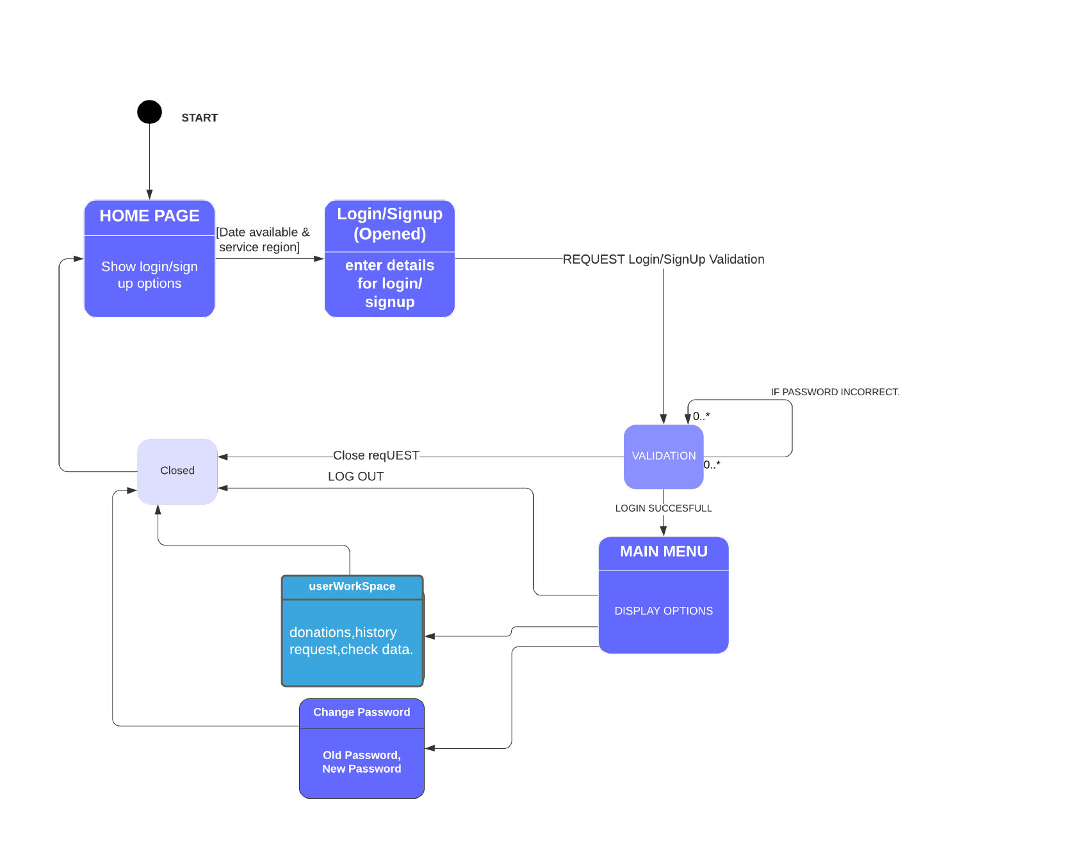

3.5. Architectural design
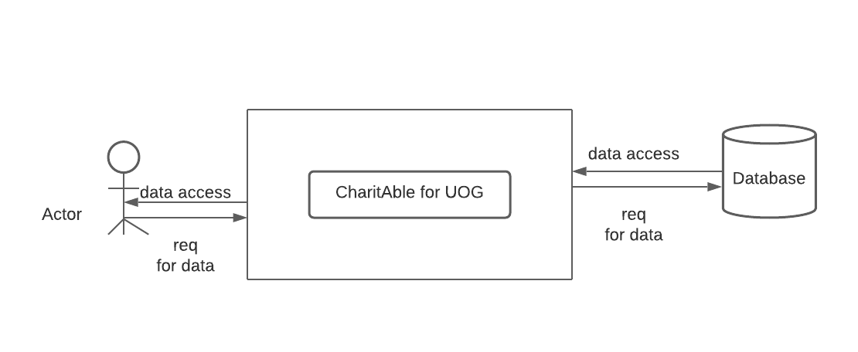

3.6. Component Level Design
→Activity Diagram for Admin
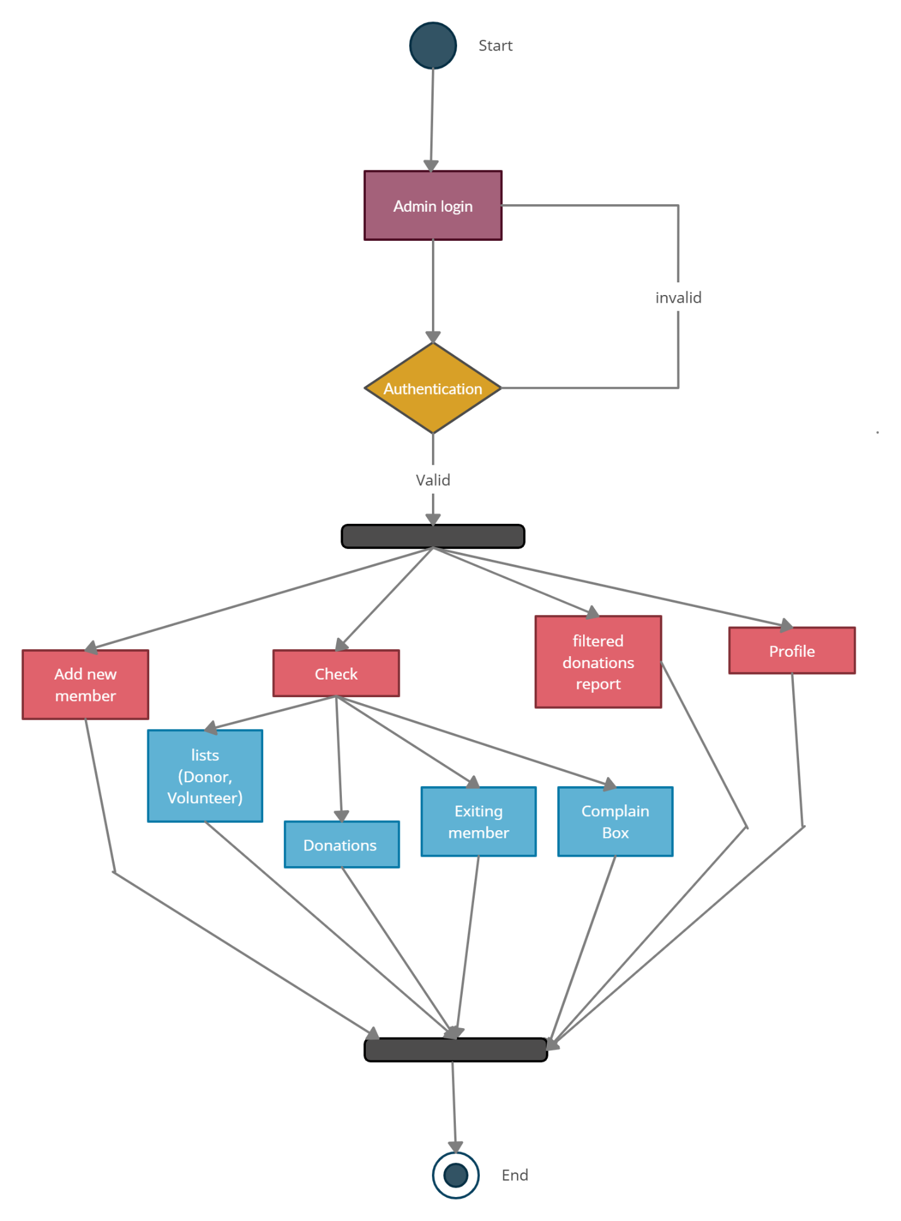→Activity Diagram for Donor
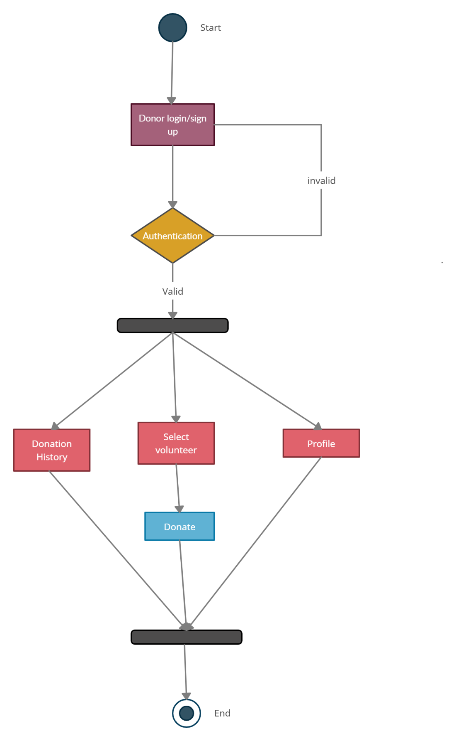
→Activity Diagram for Volunteer
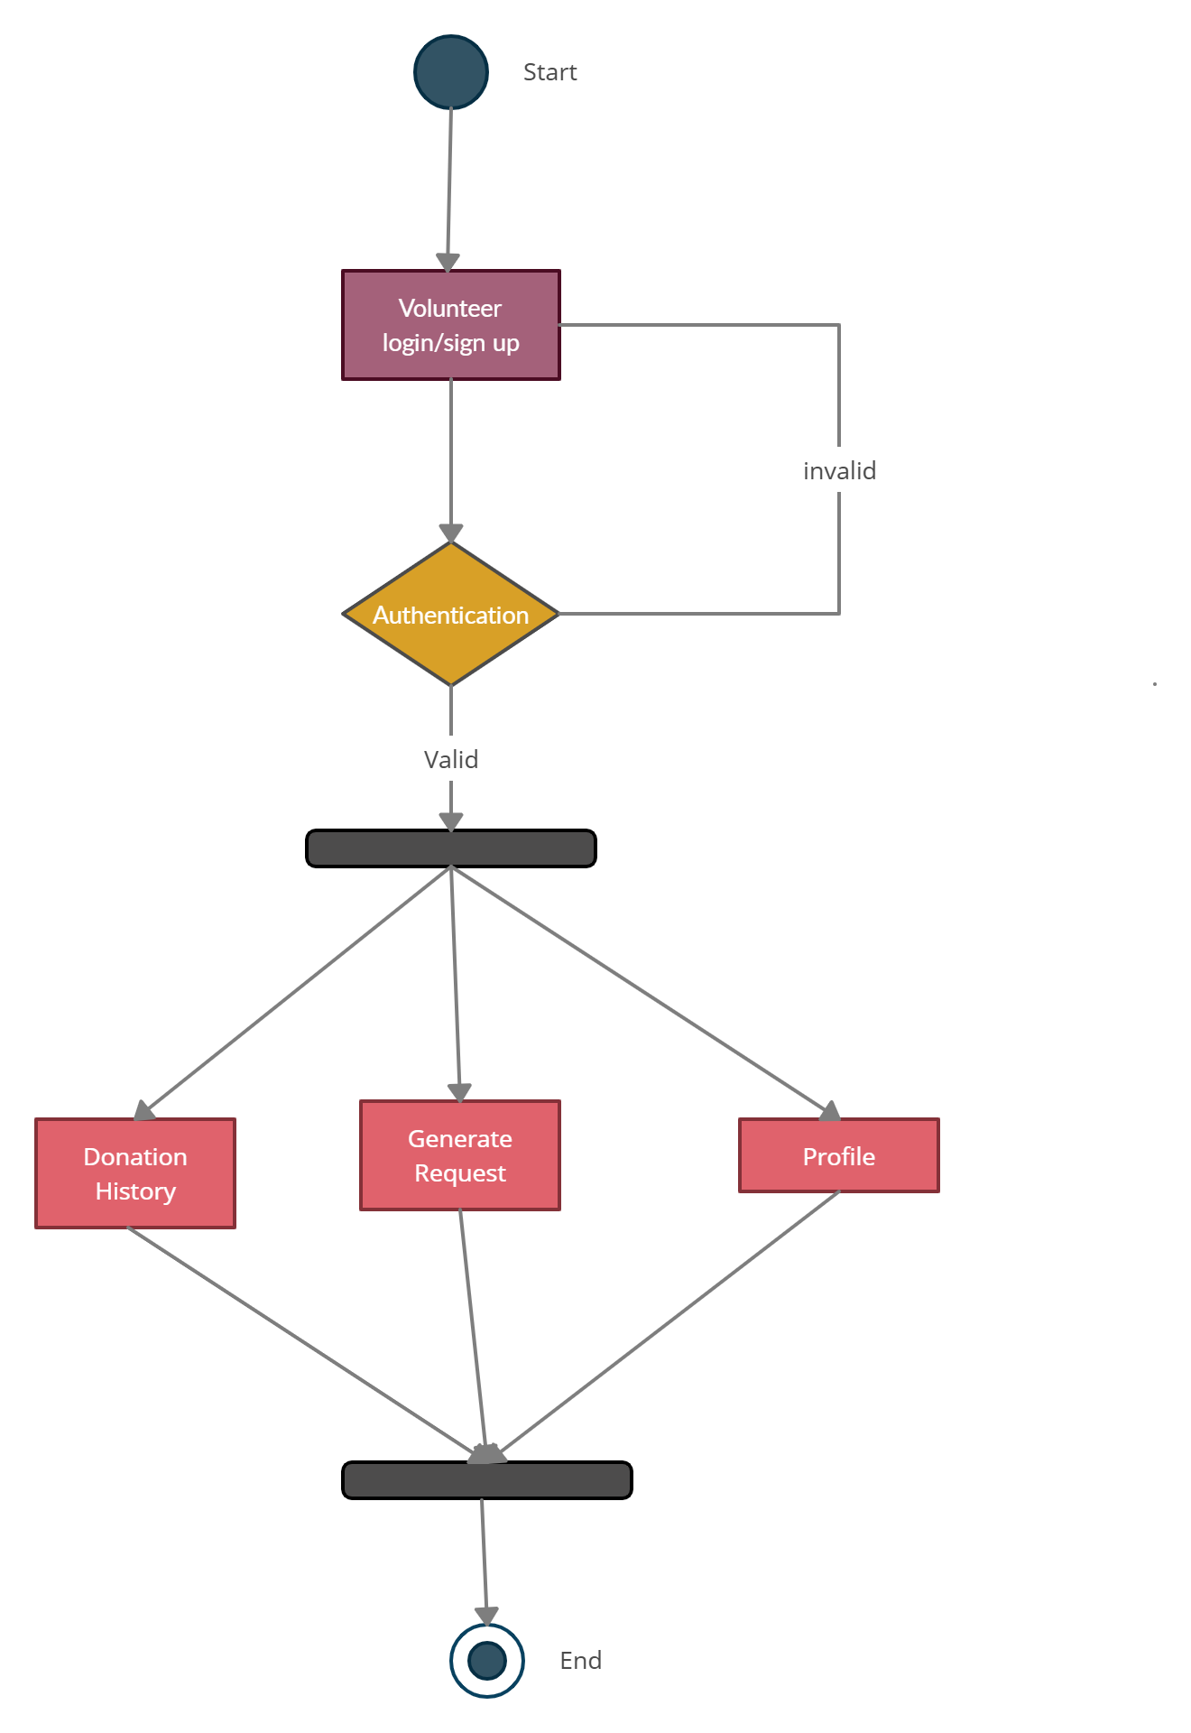

Chapter 4: User Interface Design

4.1. Introduction

A user interface design consists of three main parts:
Page elements should be visualized on paper before building them in the computer. Just as you draw a site map to plan the site, use cartoons and storyboards to begin blocking out the site’s appearance and navigational scheme.

- Site maps
- Storyboards
- Navigational maps
- Traceability Matrix

4.2. Site Maps

4.3. Story boards
A storyboard is a sequence of single images, each of which represents a distinct event or narrative. It is also a visual representation of the script illustrating the interaction between the user and the machine. It can also be imagined as a film in visual-outline form.

L1: CharitAble Login
L2: User ID
L3: Password
T1:
T2:
B1: Login
L1: label 1
L3: label 3
L3: label 3
S3: static button 3
T1: text box 1
T2: text box 2
B1: button

4.5 Trace-ability Matrix

Following columns are involved in the trace-ability matrix.

Trace-ability Matrix 1
Features | Actor logins/signup the system.
Use Case ID: | UC_01,02
Priority: | Highest
Use Case Cross Ref: | Registration
DB Table Id: | Nil
Elaborated Use-case ID: | UC_01,02
Dependent Classes: | Record Management

Trace-ability Matrix 2
Features | Actor’s donations, requests, reports, complains;  Password changing in system.
Use Case ID: | UC_3,4,5,6,7,8,9
Priority: | Medium
Use Case Cross Ref: | Record Management
DB Table Id: | Nil
Elaborated Use-case ID: | UC_3,4,5,6,7,8,9
Dependent Classes: | Login, logout

Trace-ability Matrix 3
Features | Admin does add any other admin.
Use Case ID: | UC_10,11
Priority: | low
Use Case Cross Ref: | Registration
DB Table Id: | Nil
Elaborated Use-case ID: | UC_6,7
Dependent Classes: | Managing all users tasks.

USER INTERFACE DESIGN SCREEN SHOTS

Chapter 5: Software Testing

5.1 Introduction:
This deliverable is based on the IEEE standard of software testing i.e. IEEE SOFTWARE TEST DOCUMENTATION Std 829-1998. This standard describes a set of basic test documents that are associated with the dynamic aspects of software testing (i.e., the execution of procedures and code). The standard defines the purpose, outline, and content of each basic document. While the documents described in the standard focus on dynamic testing, several of them may be applicable to other testing activities (e.g., the test plan and test incident report may be used for design and code reviews). This standard may be applied to commercial, scientific, or military software that runs on any digital computer. Applicability is not restricted by the size, complexity, or criticality of the software. However, the standard does not specify any class of software to which it must be applied. The standard addresses the documentation of both initial development testing and the testing of subsequent software releases. For a particular software release, it may be applied to all phases of testing from module testing through user acceptance. However, since all of the basic test documents may not be useful in each test phase, the particular documents to be used in a phase are not specified. Each organization using the standard will need to specify the classes of software to which it applies and the specific documents required for a particular test phase.

The standard does not call for specific testing methodologies, approaches, techniques, facilities, or tools, and does not specify the documentation of their use. Additional test documentation may be required (e.g., code inspection checklists and reports). The standard also does not imply or impose specific methodologies for documentation control, configuration management, or quality assurance. Additional documentation (e.g., a quality assurance plan) may be needed depending on the particular methodologies used.

Following are standard artifacts, which must be included in this deliverable:
- Test Plan
- Test Design Specification
- Test Case Specification
- Test Procedure Specification
- Test Item Transmittal Report
- Test Log
- Test Incident Report
- Test Summary Report

5.2. Test plan

7.2.1. Purpose
To prescribe the scope, approach, resources, and schedule of the testing activities. To identify the items being tested, the features to be tested, the testing tasks to be performed, the personnel responsible for each task, and the risks associated with this plan.

7.2.2. Outline
A test plan shall have the following structure:

- Test plan identifier
- Introduction
- Test items
- Features to be tested
- Features not to be tested
- Approach
- Item pass/fail criteria
- Suspension criteria and resumption requirements
- Test deliverables
- Testing tasks
- Environmental needs
- Responsibilities
- Staffing and training needs
- Schedule
- Risks and contingencies
- Approvals

The sections shall be ordered in the specified sequence. Additional sections may be included immediately prior to Approvals. If some or all of the content of a section is in another document, then a reference to that material may be listed in place of the corresponding content. The referenced material must be attached to the test plan or available to users of the plan.
Details on the content of each section are contained in the following sub-clauses.

5.2.2.1. Test plan identifier
Specify the unique identifier assigned to this test plan.

5.2.2.2. Introduction
Summarize the software items and software features to be tested. The need for each item and its history may be included. References to the following documents, when they exist, are required in the highest-level test plan:

- Project authorization;
- Project plan;
- Quality assurance plan;
- Configuration management plan;
- Relevant policies;
- Relevant standards.

In multilevel test plans, each lower-level plan must reference the next higher-level plan.

5.2.2.3. Test items

The items to be include e.g Contact/About us, Login, Logout, Change Password, Successful Signup, Account Approval by Admin., Generate Report, Request Now, Donations History, Donate Now, Complain Box, Lists update, Update profile

5.2.2.4. Features to be tested

The following list describes the features to be tested:

Volunteer/Donor_signup

Login

Request Now

Donate Now

Approve_donation

Change Password

Report

Complain
- Volunteer/Donor_list
- Add new member
- Existing admin

5.2.2.5. Features not to be tested
- System Performance
This is non-functional requirement. Performance of system under heavy load could not be tested due to lack of time and resources.
- System goes down
This is non-functional feature. It cannot be tested as, we cannot stimulate an actual server crash and try to recover it.

5.2.2.6. Approach
Structured approach is used:
1 .entity relationship diagram
2. Data flow diagram
3. State transition diagram
4. Architectural desig
5. Component level design

5.2.2.7. Item pass/fail criteria

All core functionality of the systems should function as expected and outlined in the individual test cases. The test cases executed on the Web based CharitAble Application

pass if they meet the specific requirements mentioned of the project. A test case is said to fail if the desired functionality is not satisfied by the system.

Item Pass Criteria:

Any Operating System which supports Browser.

Ram 4GB

Minimum Intel 4GB Graphics Card (Slow Processing)

(Optional) NVIDIA 4 GB Graphics Card ( For Good performance)

Valid Inputs and Fulfill Define Conditions.

Good Internet Connection.

Item Fail Criteria:

Using an operating system which is too old or not support Browser

Not Ram 4GB

Not Valid Inputs and Not Fulfill Define condition

Less than 4GB Graphic Card.

5.2.2.8. Suspension criteria and resumption requirements

Testing work is performed by the individual to ensure that all the functional activities are working well in the system properly. If some of these functions are not working properly in the system, the further test procedure should not be continued to the next level.

So here are some criteria for which we will pause the test work for the application.
- If a test case fails, then testing for all the dependent features will be suspended. The failed test case will be logged onto the test log which contains the description for the error.
- If system will be to handle lots of users at once.
- The testing will be resumed once the identified failure or issue is resolved.

5.2.2.9. Test deliverables
If the CharitAble Donations and request generating functions are successfully working in the web app then it will be considered pass otherwise it will be failed.
Following is list of test deliverables:
a. Test plan
b. Test design specifications
c. Test case specifications
d. Test logs
e. Test summary reports
- Test input data and test output data should be identified as deliverable.
- Test tools may also be included.

5.2.2.10. Testing tasks
- Authorization Module testing
- Login testing
- Registration testing
- Performance testing
- Account Approval by Admin testing
- Changing Password testing
- Contact to Admin Module testing.

5.2.2.11. Environmental needs
The environment requirements are as follow:
Hardware:
- Laptop and Android mobile.
- 8GB-100 GB Hard 1-4 GB Ram.
- Core i3 and later for better performance.
- Internet connectivity.
Server-side hardware:
- Core i5 and later for better performanc
- 8 GB NVIDIA Geforce RTX 3060 Graphics Card
- 16-32 GB RAM
- 2 - 8TB Hard
Software:
- Windows 8 OS and Later
- Browser i.e. Google Chrome, internet explorer, Mozilla Firefox etc.
- Python Web Server (Linux, Windows, Unix).

5.2.2.12. Responsibilities
Each member is responsible for requirements, designing, preparing documentation, developing and executing the system properly. The test manager is responsible for testing, managing and resolving the issues of the project

5.2.2.13 Staffing and training needs
Testers should conduct testing on each system. The testers should have basic knowledge about following terms before they proceed testing:
- HTML, CSS, BOOTSTRAP, JavaScript
- Python (Django Framework)
- SQLite Database

5.2.2.14. Schedule
The testing may take about one and half week to complete. Rather Some of its components and features had been tested in a two day.

5.2.2.15. Risks and contingencies
If the first component testing is not completed within a day it can be delay. After bug fixes the testing will be performed. If the tester does not have the basic understanding About HTML, CSS, BOOTSTRAP, JavaScript, SQLite Database testing will be delayed.

5.2.2.16 Approvals
The team member who manages the testing process and the team leader who manages the whole product must approve this plan. The approval of supervisor is required here: Name: Mr. Zaheer Ahmed
Title: CharitAble for U-O-G.
Signature:
Date:

5.3. Test design specification

5.3.1. Purpose
To prescribe the scope, approach, resources, and schedule of the testing activities. To identify the items being tested, the features to be tested, the testing tasks to be performed, the personnel responsible for each task, and the risks associated with this plan.

5.3.2. Outline
A test plan shall have the following structure:

- Test plan identifier;
- Introduction;
- Test items;
- Features to be tested;
- Features not to be tested;
- Approach;
- Item pass/fail criteria;
- Suspension criteria and resumption requirements;
- Test deliverables;
- Testing tasks;
- Environmental needs;
- Responsibilities;
- Staffing and training needs;
- Schedule;
- Risks and contingencies;
- Approvals.

5.3.2.1 Test plan identifier
Project Test plan CharitAble for U-O-G ChA_02.

5.3.2.2. Introduction
The main purpose of the test plan is to discuss the testing details of use cases of System. The test plan for system indicates the personnel responsible for each task and specifies the risks associated with the test plan. The goal of this document is to develop a test plan for Web-based CharitAble for U-O-G.
This document defines all procedures and activities required to prepare for testing of functions of the system which are specified in Vision document. The objectives of the test plan are to define the activities to perform testing, define test deliverable documents and to identify the various risks and contingencies involved in testing.
This test plan for Web based CharitAble for U-O-G Application testing supports the
following objectives:
- To identify the features of the system that will be tested.
- To identify the features of the system that will not be tested.
- Pass and fail criteria of the testing items.
- To communicate to the responsible parties the items to be tested, set expectations
- around schedule, and define environmental needs.
- To define how the tests will be conducted
In multilevel test plans, each lower-level plan must reference the next higher-level plan.

5.3.2.3. Test items

The items to be include e.g Contact/About us, Login, Logout, Change Password, Successful Signup, Account Approval by Admin., Generate Report, Request Now, Donations History, Donate Now, Complain Box, Lists update, Update profile

5.3.2.4. Features to be tested

The following list describes the features to be tested:

Volunteer/Donor_signup

Login

Request Now

Donate Now

Approve_donation

Change Password

Report

Complain
- Volunteer/Donor_list
- Add new member
- Existing admin

5.3.2.5. Features not to be tested
- System Performance
This is non-functional requirement. Performance of system under heavy load could not be tested due to lack of time and resources.
- System goes down
This is non-functional feature. It cannot be tested as, we cannot stimulate an actual server crash and try to recover it.

5.3.2.6. Approach
Structured approach is used:
1 .entity relationship diagram
2. Data flow diagram
3. State transition diagram
4. Architectural desig
5. Component level design

5.3.2.7. Item pass/fail criteria

All core functionality of the systems should function as expected and outlined in the individual test cases. The test cases executed on the Web based CharitAble Application

pass if they meet the specific requirements mentioned of the project. A test case is said to fail if the desired functionality is not satisfied by the system.

Item Pass Criteria:

Any Operating System which supports Browser.

Ram 4GB

Minimum Intel 4GB Graphics Card (Slow Processing)

(Optional) NVIDIA 4 GB Graphics Card ( For Good performance)

Valid Inputs and Fulfill Define Conditions.

Good Internet Connection.

Item Fail Criteria:

Using an operating system which is too old or not support Browser

Not Ram 4GB

Not Valid Inputs and Not Fulfill Define condition

Less than 4GB Graphic Card.

5.3.2.8. Suspension criteria and resumption requirements

Testing work is performed by the individual to ensure that all the functional activities are working well in the system properly. If some of these functions are not working properly in the system, the further test procedure should not be continued to the next level.

So here are some criteria for which we will pause the test work for the application.
- If a test case fails, then testing for all the dependent features will be suspended. The failed test case will be logged onto the test log which contains the description for the error.
- If system will be to handle lots of users at once.
- The testing will be resumed once the identified failure or issue is resolved.

5.3.2.9. Test deliverables
If the CharitAble Donations and request generating functions are successfully working in the web app then it will be considered pass otherwise it will be failed.
Following is list of test deliverables:
a. Test plan
b. Test design specifications
c. Test case specifications
d. Test logs
e. Test summary reports
- Test input data and test output data should be identified as deliverable.
- Test tools may also be included.

5.3.2.10. Testing tasks
- Authorization Module testing
- Login testing
- Registration testing
- Performance testing
- Account Approval by Admin testing
- Changing Password testing
- Contact to Admin Module testing.

5.3.2.11. Environmental needs
The environment requirements are as follow:
Hardware:
- Laptop and Android mobile.
- 8GB-100 GB Hard 1-4 GB Ram.
- Core i3 and later for better performance.
- Internet connectivity.
Server-side hardware:
- Core i5 and later for better performanc
- 8 GB NVIDIA Geforce RTX 3060 Graphics Card
- 16-32 GB RAM
- 2 - 8TB Hard
Software:
- Windows 8 OS and Later
- Browser i.e. Google Chrome, internet explorer, Mozilla Firefox etc.
- Python Web Server (Linux, Windows, Unix).

5.3.2.12. Responsibilities
Each member is responsible for requirements, designing, preparing documentation, developing and executing the system properly. The test manager is responsible for testing, managing and resolving the issues of the project

5.3.2.13. Staffing and training needs
Testers should conduct testing on each system. The testers should have basic knowledge about following terms before they proceed testing:
- HTML, CSS, BOOTSTRAP, JavaScript
- Python (Django Framework)
- SQLite Database

5.3.2.14. Schedule
The testing may take about one and half week to complete. Rather Some of its components and features had been tested in a two day.

5.3.2.15. Risks and contingencies
If the first component testing is not completed within a day it can be delay. After bug fixes the testing will be performed. If the tester does not have the basic understanding About HTML, CSS, BOOTSTRAP, JavaScript, SQLite Database testing will be delayed.

5.3.2.16. Approvals
The team member who manages the testing process and the team leader who manages the whole product must approve this plan. The approval of supervisor is required here: Name: Mr. Zaheer Ahmed
Title: CharitAble for U-O-G.
Signature:
Date:

5.4. Test Case Specification

5.4.1. Purpose
In order to perform effective testing, we need to create the Test Case. The effectiveness of testing is based on the way of test cases we have developed. Test cases verify the requirement is fulfilled by the application and validate the applications meets the customer needs or not. A test case allows you to define what exactly you are testing for, why you are testing and what are the associated risks.

5.4.2. Outline
A test case specification shall have the following structure:

- Test case specification identifier
- Test items
- Input specifications
- Output specifications
- Environmental needs
- Special procedural requirements
- Inter case dependencies

The sections shall be ordered in the specified sequence. Additional sections may be included at the end. If some or all the content of a section is in another document, then a reference to that material may be listed in place of the corresponding content. The referenced material must be attached to the test case specification or available to users of the case specification. Since a test case may be referenced by several test design specifications used by different groups over a long time period, enough specific information must be included in the test case specification to permit reuse.
Details on the content of each section are contained in the following sub-clauses.

5.4.2.1. Test case specification identifier
Test case specification identifier CharitAble for U-O-G ChA_03.

5.4.2.5. Environmental needs
The environment requirements are as follow:
Hardware:
- Laptop and Android mobile.
- 8GB-100 GB Hard 1-4 GB Ram.
- Core i3 and later for better performance.
- Internet connectivity.
Server-side hardware:
- Core i5 and later for better performanc
- 8 GB NVIDIA Geforce RTX 3060 Graphics Card
- 16-32 GB RAM
- 2 - 8TB Hard

Software:
- Windows 8 OS and Later
- Browser i.e. Google Chrome, internet explorer, Mozilla Firefox etc.
- Python Web Server (Linux, Windows, Unix).

5.4.2.7. Inter case dependencies
Test case Id | Dependency
TC-1 | None
TC-2 | TC-1
TC-3 | TC-2
TC-4 | TC-2,3
TC-5 | TC-4
TC-6 | TC-2
TC-7 | TC-2
TC-8 | TC-2
TC-9 | TC-2
TC-10 | TC-2
TC-11 |  | TC-2,10

5.5. Test procedure specification

5.5.1. Purpose
To specify the steps for executing a set of test cases or, more generally, the steps used to analyze a software item in order to evaluate a set of features.

5.5.2 Outline
A test procedure specification shall have the following structure:

- Test procedure specification identifier
- Purpose
- Special requirements
- Procedure steps

The sections shall be ordered in the specified sequence. Additional sections, if required, may be included at the end. If some or all of the content of a section is in another document, then a reference to that material may be listed in place of the corresponding content. The referenced material must be attached to the test procedure specification or available to users of the procedure specification.
Details on the content of each section are contained in the following sub clauses.

5.5.2.1. Test procedure specification identifier
Test procedure specification identifier CharitAble for U-O-G ChA_04.

5.5.2.2. Purpose
This module describes the testing procedures and the whole testing process. By looking at this module, a person will learn how to execute the testing procedures of a management system. This procedure executes following test cases TC-1, 2, 6…, 11.

5.5.2.3. Special requirements
Front-end and Back-end testing would be on a manual. None of special requirements required.

5.5.2.4. Procedure steps
- Working WebApp
- DataBase Connectivity

Login

Logout

Change Password

Successful Signup

Account Approval by Admin.

Generate Report

Request Now

Donations History

Donate Now

Complain Box
- Lists update

Update profile

5.5.2.4.1. Log
It describes any special methods or formats for logging the results of test execution, the incidents observed, and any other events pertinent to the test that are already described in previous section

5.5.2.4.2. Set up
- 2. Install tools for development
- Verify whether these are installed properly
- Start Testing.

5.5.2.4.3. Start

We need to start php, CSS, HTML, JavaScripting for front and for backend end and create a database to store data.

5.5.2.4.4. Proceed

Access the website of Deep Fake App. Regiser, Login. Select user workspace from nav bar and Run test cases in dependency order:

Test cases with no dependencies or solved dependencies first.

Test case Id | Dependency
TC-1 | None
TC-2 | TC-1
TC-3 | TC-2
TC-4 | TC-2,3
TC-5 | TC-4
TC-6 | TC-2
TC-7 | TC-2
TC-8 | TC-2
TC-9 | TC-2
TC-10 | TC-2
TC-11 |  | TC-2,10

5.5.2.4.5. Measure

Measurement system is based on human observation mostly, so log what we see on the screen, if something goes wrong.

5.5.2.4.6. Shut down
Stop CharitAble by closing DataBase Access and by blocking the accounts .

5.5.2.4.7. Restart

Refresh the Browser to Restart the process. For example, After new user registration to system when admin wants to revise the user record for modification, test procedure began to restart.

5.5.2.4.8. Stop
After running all test cases according to inter case dependency it will stop the process by
Stopping data access.

5.5.2.4.9. Wrap up

Report hours and check that test log is written. E.g. If any information is missed or update any record, it gives user to move on this task revise as restore point.

5.5.2.4..10. Contingencies
We need to submit bug reports. Test manager will use that information to create incident reports.

5.6. Test item transmittal report

5.6.1. Purpose
To identify the test items being transmitted for testing. It includes the person responsible for each item, its physical location, and its status. Any variations from the current item requirements and designs are noted in this report.

5.6.2. Outline
A test item transmittal report shall have the following structure:

- Transmittal report identifier
- Transmitted items
- Location
- Status
- Approvals

The sections shall be ordered in the specified sequence. Additional sections may be included just prior to Approvals. If some or all of the content of a section is in another document, then a reference to that material may be listed in place of the corresponding content. The referenced material must be attached to the test item transmittal report or available to users of the transmittal report.
Details on the content of each section are contained in the following sub clauses.

5.6.2.1. Transmittal report identifier
Transmittal report identifier CharitAble for U-O-G ChA_05.

5.6.2.2. Transmitted items
The transmitted items refer to Test Plan
List of Items being transmitted to the test plan.

Volunteer/Donor_signup

Login

Request Now

Donate Now

Approve_donation

Change Password

Report

Complain
- Volunteer/Donor_list
- Add new member
- Existing admin

5.6.2.3. Location
All transmitted test case design referenced in the report are located

Transmitted items in test case design | Location
Volunteer/Donor_signup | 2.2.11.1
login | 2.2.11.2
Request Now | 2.2.11.3
Donate Now | 2.2.11.4
Approve_donation | 2.2.11.5
Change Password | 2.2.11.6
Report | 2.2.11.7
Complain | 2.2.11.8
Volunteer/Donor_list | 2.2.11.9
Add_New_member | 2.2.11.10
Existing_Admin | 2.2.11.11

5.6.2.4. Status

Transmitted items in test case design | Test Case ID | Location | Status
Volunteer/Donor_signup | TC-1 | 2.2.11.1 | pass
login | TC-2 | 2.2.11.2 | Pass
Request Now | TC-3 | 2.2.11.3 | Pass
Donate Now | TC-4 | 2.2.11.4 | Pass
Approve_donation | TC-5 | 2.2.11.5 | Pass
Change Password | TC-6 | 2.2.11.6 | Pass
Report | TC-7 | 2.2.11.7 | Pass
Complain | TC-8 | 2.2.11.8 | Pass
Volunteer/Donor_list | TC-9 | 2.2.11.9 | Pass
Add_New_member | TC-10 | 2.2.11.10 | Pass
Existing_Admin | TC-11 | 2.2.11.11 | pass

5.6.2.5. Approvals
The team member who manages the testing process and the team leader who manages the whole product must approve this plan. The approval of supervisor is required here: Name: Mr. Zaheer Ahmed
Title: CharitAble for U-O-G.
Signature:
Date:

5.7. Test log

5.7.1. Purpose
To provide a chronological record of relevant details about the execution of tests.

5.7.2. Outline
A test log shall have the following structure:
- Test log identifier;
- Description;
- Activity and event entries.

The sections shall be ordered in the specified sequence. Additional sections may be included at the end. If some or all of the content of a section is in another document, then a reference to that material may be listed in place of the corresponding content. The referenced material must be attached to the test log or available to users of the log. Details on the content of each section are contained in the following sub clauses.

5.7.2.1. Test log identifier
Test log identifier CharitAble for U-O-G ChA_06.

5.7.2.2. Description
Test  Case  Id | Test Case Name | Tester  Name | Date | Software | Hardware
TC-1 | Volunteer/Donor_signup | Awais | 10-6-21 | Window  7 or  above | Core i3 Processor and 2 GB Ram  Recommended
TC-2 | Login | Qandeel | 10-6-21 | Window  7 or  above | Core i3 Processor and 2 GB Ram  Recommended
TC-3 | Request Now | Iqra | 11-6-21 | Window  7 or  above | Core i3 Processor and 2 GB Ram  Recommended
TC-4 | Donate Now | Awais | 12-6-21 | Window  7 or  above | Core i3 Processor and 2 GB Ram  Recommended
TC-5 | Approve donation | Qandeel | 13-6-21 | Window  7 or  above | Core i3 Processor and 2 GB Ram  Recommended
TC-6 | Change Password | Iqra | 14-6-21 | Window  7 or  above | Core i3 Processor and 2 GB Ram  Recommended
TC-7 | Report | Awais | 15-6-20 | Window  7 or  above | Core i3 Processor and 2 GB Ram  Recommended
TC-8 | Complain | Qandeel | 16-6-21 | Window  7 or  above | Core i3 Processor and 2 GB Ram  Recommended
TC-9 | Volunteer/Donor_list | Iqra | 17-6-21 | Window  7 or  above | Core i3 Processor and 2 GB Ram  Recommended
TC-10 | Add_New_member | Awais | 18-6-21 | Window  7 or  above | Core i3 Processor and 2 GB Ram  Recommended
TC-11 | Existing_Admin | Qandeel | 19-6-21 | Window  7 or  above | Core i3 Processor and 2 GB Ram  Recommended

5.7.2.3. Activity and event entries
Activity | Start Date | End Date
Volunteer/Donor_signup | 10-6-21 | 10-6-21
Login | 10-6-21 | 10-6-21
Request Now | 11-6-21 | 11-6-21
Donate Now | 12-6-21 | 12-6-21
Approve donation | 13-6-21 | 13-6-21
Change Password | 14-6-21 | 14-6-21
Report | 15-6-21 | 15-6-21
Complain | 16-6-21 | 16-6-21
Volunteer/Donor_list | 17-6-21 | 17-6-21
Add_New_member | 18-6-21 | 18-6-21
Existing_Admin | 19-6-21 | 19-6-21

5.7.2.3.1. Execution description
Activities | Description
Volunteer/Donor_signup | ● | Enter first Name, last Name, Email, username, password, confirm password, and your pourpose to use this app.
 | ● | Then click sign up
 | ● | System will welcome you.
Log in | ● | Enter usename and password.
 | ● | Click login.
 | ● | Click on request now
Request Now | ● | Fill the form
Donate Now | ● | Click on donate now
 | ● | Check request list and select volunteer.
Approve donation | ● | Click accept donation
 | ●
Change password | ● | Enter username current password, new password and confirm new password
Report | ●   | click on report to generate a donations report.
Complain | ● | Click on complain to response on complains.
Volunteer/Donor_list | ● | Actor can check the list of volunteers and donors
Add new member | ● | Actor can add new member
Existing admin | ● | Actor can check other admin list who are added by the admin

5.7.2.3.2. Procedure results

Transmitted items in test case design | Test Case ID | Location | Status
Volunteer/Donor_signup | TC-1 | 2.2.11.1 | pass
login | TC-2 | 2.2.11.2 | Pass
Request Now | TC-3 | 2.2.11.3 | Pass
Donate Now | TC-4 | 2.2.11.4 | Pass
Approve_donation | TC-5 | 2.2.11.5 | Pass
Change Password | TC-6 | 2.2.11.6 | Pass
Report | TC-7 | 2.2.11.7 | Pass
Complain | TC-8 | 2.2.11.8 | Pass
Volunteer/Donor_list | TC-9 | 2.2.11.9 | Pass
Add_New_member | TC-10 | 2.2.11.10 | Pass
Existing_Admin | TC-11 | 2.2.11.11 | pass

5.7.2.3.3. Environmental information
The environment requirements are as follow:
Hardware:
- Laptop and Android mobile.
- 8GB-100 GB Hard 1-4 GB Ram.
- Core i3 and later for better performance.
- Internet connectivity.
Server-side hardware:
- Core i5 and later for better performanc
- 8 GB NVIDIA Geforce RTX 3060 Graphics Card
- 16-32 GB RAM
- 2 - 8TB Hard

Software:
- Windows 8 OS and Later
- Browser i.e. Google Chrome, internet explorer, Mozilla Firefox etc.
- Python Web Server (Linux, Windows, Unix).

5.7.2.3.4. Anomalous events
None of Anomalous events.

5.7.2.3.5. Incident report identifiers
Test incident report identifier CharitAble for U-O-G ChA_07.

5.8. Test incident report

5.8.1. Purpose
To document any event that occurs during the testing process that requires investigation.

5.8.2. Outline
A test incident report shall have the following structure:

- Test incident report identifier
- Summary
- Incident description
- Impact

The sections shall be ordered in the specified sequence. Additional sections may be included at the end. If some or all of the content of a section is in another document, then a reference to that material may be listed in place of the corresponding content. The referenced material must be attached to the test incident report or available to users of the incident report.
Details on the content of each section are contained in the following sub clauses.

5.8.2.1. Test incident report identifier
Test incident report identifier CharitAble for U-O-G ChA_08.

5.8.2.2. Summary
All the items are tested for ‘CharitAble for U-O-G’. The testing of this system
is conducted by user and admin and testing of front end is conducted manually. When testing the system’s features, there was an anomalous event occurred. But later that was fixed.

5.8.2.3. Incident description
Provide a description of the incident. This description should include the following items:
- Inputs
- Expected results
- Actual results
- Anomalies
- Date and time;
- Procedure step;
- Environment;
- Attempts to repeat;
- Testers;
- Observers.

Inputs | Expected result | Actual result | Anomali es | Date &  Time | Proced ure Step | Environmen  t | Attempts to repeat | Teste rs | Observers
Enter username and password for Login | Login should  be Successful  . | Login was  Successful  . | Use of  local  API | 10-6-21 | Login system should be working  properl y | Core i3Processor ,  2 Gb Ram and active  Internet connection Recommend | 2  times  repeated | 1  tester | 1 observer

5.8.2.4.Impact
If known, indicate what impact this incident will have on test plans, test design specifications, test procedure specifications, or test case specifications.

5.9. Test summary report

5.9.1. Purpose
To summarize the results of the designated testing activities and to provide evaluations based on these results.

5.9.2. Outline
A test summary report shall have the following structure:
- Test summary report identifier
- Summary
- Variances
- Comprehensive assessment
- Summary of results
- Evaluation
- Summary of activities
- Approvals

The sections shall be ordered in the specified sequence. Additional sections may be included just prior to Approvals. If some or all of the content of a section is in another document, then a reference to that material may be listed in place of the corresponding content. The referenced material must be attached to the test summary report or available to users of the summary report.
Details on the content of each section are contained in the following sub clauses.

5.9.2.1. Test summary report identifier
Test summary report identifier CharitAble for U-O-G ChA_09.

5.9.2.2. Summary
All components were tested, no such big issue is found that effects the system. And now, each component is working properly.

5.9.2.3. Variances
Variance of links occurred.

5.9.2.4. Comprehensiveness assessment
The testing process is done exactly like described in the test plan. All the workable features described in the test plan are tested. The testing process is done exactly like described in the test plan. All the features described in the test plan are tested.

5.9.2.5. Summary of results
All results according to project requirements and functioning properly.

5.9.2.6. Evaluation
Testing process was simple and sufficient for every phase. We reached a conclusion that all functionality of system is working Properly.

5.9.2.7. Summary of activities
Unit testing was completed on following dates for major module:

Volunteer/Donor_signup 1-07-2021

Login 1-07-2021

Request Now 1-07-2021

Donate Now 2-07-2021

Approve_donation 2-07-2021

Change Password 2-07-2021

Report 3-07-2021

Complain 3-07-2021
Volunteer/Donor_list 3-07-2021
Add new member 4-07-2021
Existing admin 4-07-2021

5.9.2.8. Approvals

Name | Title | Signature | Date
Mr. Zaheer Ahmed | CharitAble for U-O-G |  | 14-07-2021

Appendixes:

Appendix 1: Final Documentation Format Guidelines
Typographical Format and Binding
Page Format:

Page size: A4
Top margin: 1.00 inch
Bottom margin: 1.00 inch
Left margin: 1.25 inch
Right margin: 1.00 inch

Page numbering: Bottom right - part of the footnote
Title page not numbered
All other pages before the page of chapter one numbered in lower roman numerals (i, ii, iii, …)
All other pages starting from first page of chapter one to last page of the report numbered in integers (1, 2, 3, …)

Footer: Each page shall have a footnote “Division of Science & Technology, University of Education, Lahore”
Left aligned
In case of long titles shorter versions should be used.
There shall be a line over the footnote.

Header: Each page shall have a header “Project Name”
Left aligned
In case of long titles shorter versions should be used.
There shall be a line under the footnote.

Chapter Startup: Each chapter shall be numbered as Chapter 1, Chapter 2, etc. The name of the chapter shall be written immediately below. Both shall be centered horizontally as well as vertically.
The actual chapter content shall start from the next page.7

Text: Only one side of the paper shall be used.
The other side shall be blank.
When a report is opened the right side would contain text, figures, or tables and the left side would be blank.

Tables and Figures: Tables and figures shall be placed on one side only
Separate pages shall be used for figures and tables.
One page may contain more than one figure or table but text will not be combined or interlaced with figure or table.
Each table / figure shall be numbered.
For example "Table 1.2: Population distribution in Asia" or "Figure 3.2: Temperature distribution"
The table number or figure number shall be placed as normal text centered at the bottom of the table or figure or sideways with table / figure title coming on the opening side of the paper and note on the binding side.

Paragraph:

Single-spaced.
Line entered paragraph.
DONOT put indents at the beginning of the paragraph.
Left aligned or justified.

Text Format

Normal and plane text:
Font Type: Times New Roman
Font Size: 12
Headings:
Chapter Heading: Times New Roman Bold Size 16 Title Case normal
Heading 1: Times New Roman Bold Size 14 Title Case normal
Heading 2: Times New Roman Bold Size 12 Title Case normal
Heading 3: Times New Roman Bold Size 12 Title Case italic

Sections and Subsections

In case of sections and subsections follow this format:

1 Section
1.1 Sub Section
1.1.1 Nested Sub Section
a
b
i
ii

The subsequent reference to a any section shall be made using the section and its number. For example section 2.1.3 means chapter 2 section 1 subsection 3.

Mathematical Equations

The following numbering scheme should be used to number the equations:
f(x) = x+3 (XX:YY)
Where XX is the chapter number and YY is the sequence number of that equation in that chapter.
If an equation is previously quoted in an earlier chapter, say as equation 4:5 and need to be re-quoted in chapter 5, its number will remain as equation 4:5.

References

References are to be placed in square brackets and interlaced in the text. For example "A comprehensive detail of how to prevent accidents and losses caused by technology can be found in the literature [1]. A project report / thesis cannot be accepted without proper references. The references shall be quoted in the following format:

The articles from journals, books, and magazines are written as:
[1] Abe, M., S. Nakamura, K. Shikano, and H. Kuwabara. Voice conversion through vector quantization. Journal of the Acoustical Society of Japan, April 1990, E-11 pp 71-76.
[2] Hermansky, H. Perceptual linear predictive (PLP) analysis for speech. Journal of the Acoustical Society of America, January 1990, pp 1738-1752.
The books are written as:
[1] Nancy G. Leveson, Safeware System Safety and Computers, A guide to preventing accidents and losses caused by technology, Addison-Wesley Publishing Company, Inc. America, 1995.
[2] Richard R. Brooks, S. S. Iyengar, Multi-Sensor Fusion Fundamentals and Applications with Software, The Prentice-Hall Inc. London, 1998.

Binding

All reports shall be bounded with an appropriate print on the backbone.
Two copies should be submitted.

Color of the binding:
- BSc project / thesis reports: black
- MSc project / thesis reports: blue

Contents of the CD Attached
All reports / theses must accompany a CD whose contents will have the following:

Top-level directories:
Doc All documents related to the project
Instructions how to access the CD to the point to running the project
All reports already submitted
The final project report in thesis form
Installation instructions
Trouble shooting instructions in case of problems
User manual
Research material including URLs
Papers consulted / referred to
Slides of the presentations
Source All source files that will be needed to compile the project.
Further subdirectories can be used.
This must include sample data files as well.
Project The running project including sample data files as well as sample output.
This should be in a form that if copied to a machine runs without errors.
This may an exe file of an entire project, an installer depending on the project or simply a running project.
You can have sub directories with appropriate names.

Length
The length of your dissertation depends on the type of project you have selected. An excellent dissertation will often be brief but effective (its author will have said a lot in a small amount of space). Voluminous data can be submitted electronically on CD.

